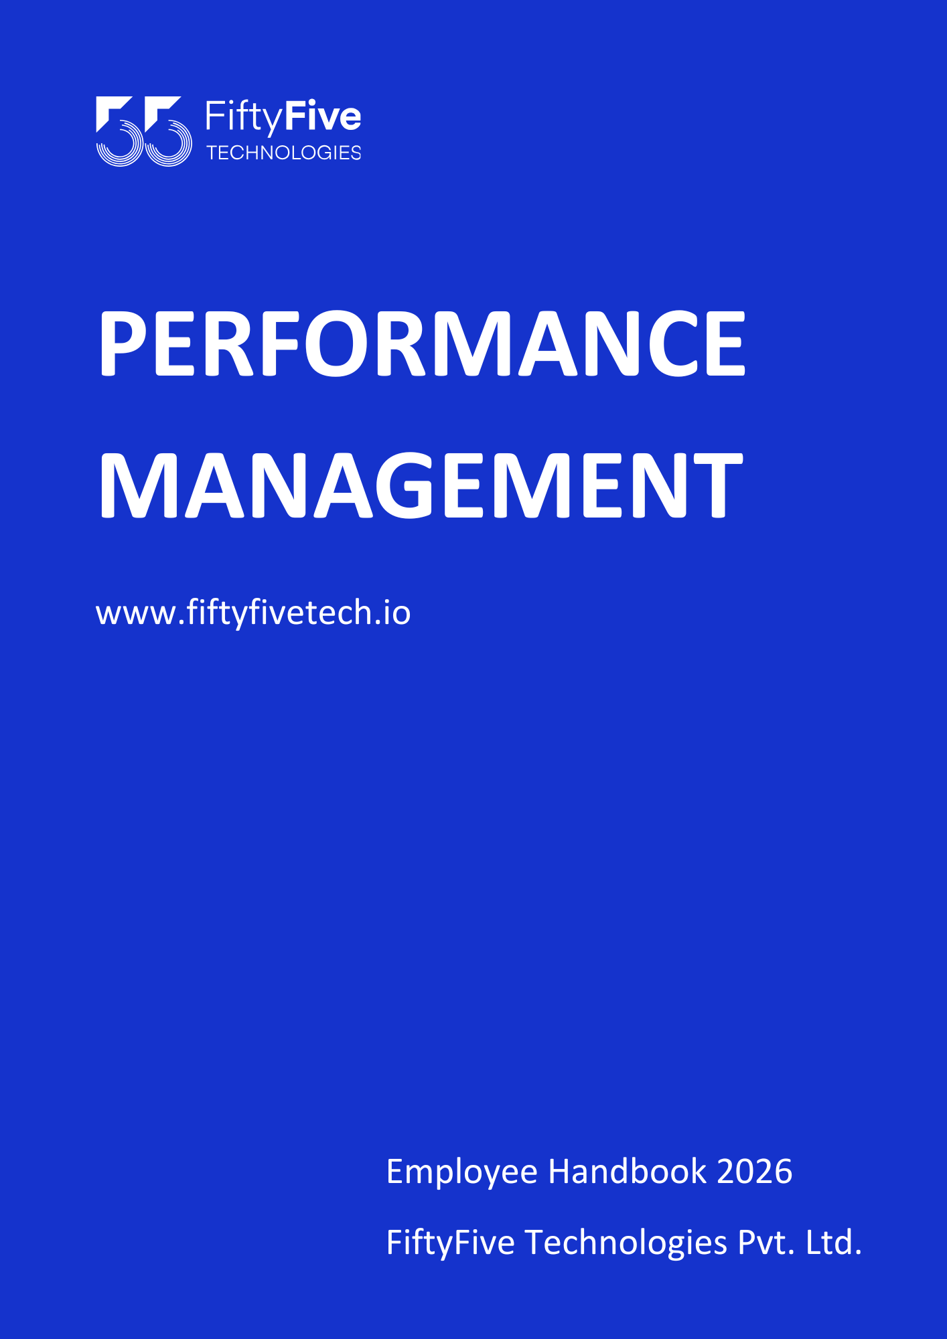

PERFORMANCE MANAGEMENT

Document Release Notice

This FiftyFive Technologies Policy on performance management system is released for use in FiftyFive Technologies Pvt Limited with effect from 01 January 2026.

This document is subject to FiftyFive Technologies Pvt Limited Procedure and subject to change at any time as per the company policy.

Approved By: Jyothi Sharma (CEO-FiftyFive Technologies Pvt. Limited)
Approved By: Sanchi Saxena (Head HR-FiftyFive Technologies Pvt Limited)

PERFORMANCE MANAGEMENT SYSTEM
Introduction
The Performance Management System (PMS) is designed to establish a structured and continuous process for evaluating employee performance in alignment with the Company’s objectives, values, and business goals. The system aims to promote accountability, encourage continuous improvement, and support employee development through regular performance assessments and feedback.
The PMS provides a fair and objective framework to measure individual contributions, identify strengths and areas for improvement, and link performance outcomes with career growth, learning opportunities, and rewards, wherever applicable. Performance evaluations under this system are conducted in a transparent, merit-based, and consistent manner, while considering organizational requirements and role expectations.
The Company reserves the right to modify, implement, or review the Performance Management System at its discretion to ensure effectiveness, business alignment, and sustained organizational growth.

Definitions
For the purpose of this policy:
- Performance Management System (PMS): A structured process for planning, monitoring, evaluating, and improving employee performance.
- Performance Improvement Plan (PIP): A formal, time-bound plan initiated to address performance gaps and provide structured support to enable improvement.
- Appraisal Cycle: The defined period during which employee performance is reviewed for appraisal and reward consideration.
- Reporting Manager: The immediate supervisor responsible for managing, evaluating, and providing feedback on an employee’s performance.
- Loss of Pay (LOP): Leave availed without pay, resulting in a proportional salary deduction for the applicable period.
- Probation: The initial employment period during which confirmation is subject to satisfactory performance.

Applicability
This Performance Management System is applicable to all full-time employees of the Company, unless otherwise specified. Employees on probation, internship, or contractual engagement may be covered under a separate evaluation process or as defined in their respective employment terms.
Participation in the Performance Management System is mandatory for all applicable employees and forms an integral part of performance reviews, appraisals, and other employment-related decisions.

Documentation and Record Maintenance
All documentation related to PMS, including performance reviews, appraisal records, feedback, PIPs, written notices, review meeting minutes, and outcomes, shall be formally documented and maintained by the HR Department.
These records shall be retained for internal reference, compliance, audits, and decision-making purposes and may be used in matters related to appraisals, disciplinary action, or separation, as applicable.

Provisions:
- Performance Evaluation Criteria
Employee performance shall be assessed based on, but not limited to, the following
- Achievement of assigned goals and targets
- Quality and timeliness of work
- Skills, competency, and role effectiveness
- Attendance, discipline, and adherence to Company policies
- Collaboration, communication, and professional conduct
- Demonstration of Company values and culture

Roles and Responsibilities
- Employee Responsibilities:
- Actively participate in the PMS process
- Work towards agreed goals and performance expectations
- Seek and accept constructive feedback
- Maintain professionalism and transparency during evaluations.

- Reporting Manager Responsibilities:
- Set clear performance expectations and goals
- Provide timely feedback and guidance
- Conduct fair, objective, and unbiased evaluations
- Recommend development plans and performance outcomes

- HR Responsibilities:
- Facilitate and administer the PMS process
- Ensure consistency, fairness, and confidentiality
- Maintain records related to performance evaluations
- Support employees and managers during the PMS cycle

- Performance Cycle
- Salary appraisals may be considered upon completion of one (1) year, i.e., 12 months of continuous service with the Company.
- The appraisal process is entirely performance-driven and discretionary. The Company is not obligated to conduct appraisals at a fixed time or on a mandatory basis.
- All information related to salary appraisals, increments, and compensation is strictly confidential and has a long-term impact on the Company’s working environment and culture.
- Employees are expected to maintain confidentiality regarding their wages and appraisal outcomes as part of the performance review process.
- Any discussion or disclosure of increments and/or salary hikes among colleagues is strictly prohibited. If such instances are observed, the Company may initiate strict disciplinary action against the concerned parties, which may include withdrawal of increment, reduction of the current CTC, or other appropriate action, as deemed necessary, for adversely affecting the Company’s work environment.
- Approved increments, if any, shall be effective from the employee’s appraisal of month and date, upon completion of one year of service.

Appraisal on Resignation During Appraisal Cycle
- In the event an employee submits their resignation during the appraisal cycle or at the time when their appraisal becomes due, the appraisal process shall be kept on hold.
- Due to the employee’s resignation shall not be initiated, processed, or finalized, and the employee shall not be eligible for any appraisal-related benefits, including salary revision, increment, or performance-based rewards.
- Any appraisal under such circumstances shall be considered null and void, and no retrospective or pro-rata appraisal benefits shall be applicable during the notice of period or resignation of tenure.
- The Company reserves the right to make the final decision in such cases based on business requirements and policy discretion.

Performance Feedback and Development
The PMS encourages continuous feedback and communication between employees and managers. Based on performance outcomes, employees may be guided through:
- Skill development initiatives
- Training and learning opportunities
- Performance improvement plans (if required)
Linkage to Appraisal and Rewards
Performance outcomes under the PMS may be considered for:
- Salary appraisals and increments
- Promotions or role enhancements
- Recognition and rewards
All appraisal-related decisions remain at the sole discretion of the Company and are subject to business needs and policy guidelines.

- Performance Improvement Plan
The performance improvement plan is a key aspect of the Performance Management System in FiftyFive Technologies. An important outcome of the employee's further professional development and motivates him or her to continuously improve the performance. An important aspect is standard and assists them to improve the same. This is achieved through the administration of the Performance Improvement Plan.
A Performance Improvement Plan (PIP) may be initiated when an employee’s performance consistently falls below the expected standards or when significant performance gaps are identified.
- Key aspects of the PIP include:
- Clearly defined performance gaps and improvement areas
- Specific, measurable goals and expectations
- Support mechanisms such as training, coaching, or mentoring
- A defined review period, typically ranging from 15 days to 90 days, as determined by the Company
- Regular progress reviews and documented feedback.

- Work Performance Definitions:

Unsatisfactory Work Performance: Unsatisfactory Work Performance may include, but is not limited to, the following behaviors:
- Inability to complete assigned tasks or correct errors within a reasonable timeframe
- Inability or unwillingness to learn new tasks or skills or to work collaboratively
- Inability to exercise sound judgment
- Inability to receive, understand, or follow instructions or directions
- Unprofessional behavior as a team member or in a managerial role

Average Work Performance: Average Work Performance may include, but is not limited to, the following behaviors:
- Inability to consistently complete all assigned tasks or correct errors within a reasonable timeframe
- Inconsistent willingness or ability to learn new tasks or collaborate
- Inability to consistently exercise good judgment
- Inability to fully receive, understand, or follow instructions or directions
- Unprofessional behavior as a team member or manager on more than one occasion.

Satisfactory Work Performance: Satisfactory Work Performance may include, but is not limited to, the following behaviors:
- Ability to complete assigned tasks or correct errors within a reasonable timeframe
- Willingness and ability to learn new tasks or skills and work collaboratively
- Ability to exercise sound judgment
- Ability to receive, understand, and follow instructions or directions
- Professional behavior as a team member or in a managerial role.

- Leave Clause During Performance Improvement Plan (PIP)

- During the Performance Improvement Plan (PIP) period, all leave balances as defined under the Leave Policy of FiftyFive Technologies, including monthly leave and additional leave entitlements, shall be kept on hold. This period is specifically intended for the employee to focus exclusively on performance improvement and meeting the defined expectations.
- Employees under an active PIP shall not be permitted to avail any type of leave during the PIP duration.
- In the event of genuine emergency situations, the employee may avail strictly on a Loss of Pay (LOP) basis, subject to prior approval from the Reporting Manager and the HR Department.
- Any LOP availed during the PIP period shall not be converted, adjusted, or reversed against Casual Leave, Privilege Leave, or any other leave balance, even after successful completion or closure of the PIP.
- Normal leave eligibility and balances shall be reinstated only after the formal closure of the PIP and subject to satisfactory performance improvement.

- Pre-Performance Improvement Plan:
Before initiating a formal PIP, the Reporting Manager must address performance concerns through informal discussions, guidance, and coaching. These discussions must be supported by documented evidence such as emails, feedback notes, or meeting records.
If the informal approach does not result in satisfactory improvement, the Reporting Manager shall inform the HR Team, and the matter shall proceed to the formal PIP stage.

Initiation of Performance Improvement Plan

Written Notice
Once the formal PIP is initiated, the employee shall receive a written notice, with the Reporting Manager and HR Team involved. The notice shall clearly outline:
- Areas of improvement identified by the Reporting Manager
- Duration of the PIP, typically ranging between 15 to 90 days
(The final decision on the PIP duration shall rest with the Reporting Manager, in consultation with HR)
- Applicable terms and conditions during the PIP period, including forfeiture of any bonus or incentive for the month
- Support measures to be provided, such as additional training, supervision, coaching, or peer support
- Consequences of failure to demonstrate improvement within the review period.

Conditions During the PIP Period
- Employees under an active PIP are not eligible to opt for or avail any type of leave
- Employees shall not be eligible for appraisal, salary increment, promotion, or bonus during the PIP period
- Employees are expected to strictly adhere to performance expectations and cooperate fully with the PIP process.

Performance Review Meeting
At the end of the PIP review period, a Performance Review Meeting shall be conducted. The meeting shall be led by the Immediate Reporting Manager or Project Manager, and the Head of Human Resources shall also be present.

Outcomes of the Performance Review

a) Satisfactory Improvement
Potential Outcome:
If the Reporting Manager determines that the employee has met the required performance standards, no further corrective action shall be taken, and the PIP shall be considered cleared.
Action:
The employee shall continue under observation for the next three (3) months to ensure sustained performance.

b) Partial Improvement
Potential Outcome:
If significant improvement is observed and performance standards are likely to be met shortly, the PIP period may be extended.
Action:
- Extension of the PIP shall be communicated in writing
- Revised terms and duration shall be clearly outlined
- Additional training or support may be recommended
- A new performance review meeting date shall be scheduled

c) No Improvement / Insufficient Improvement
Potential Outcome:
If there is no overall improvement or performance that remains below the required standard, the matter shall be formally escalated to HR.
Action:
- HR shall proceed with separation of the employee from the organization in accordance with the Company’s separation policy.
- Final salary settlement and issuance of the Experience Letter shall be governed by the applicable separation clause.
- The Company reserves the right to make the separation effective immediately.

- PIP Provisions and Confidentiality
  - During the Performance Improvement Plan (PIP) period, employees shall not be eligible to avail any type of leave.
  - An employee may be issued a maximum of three (3) Performance Improvement Plans (PIPs) during their entire tenure with the Company.
  - Under no circumstances shall an employee be placed under a Performance Improvement Plan (PIP) more than three (3) times during their tenure with the Company. In the event that performance concerns continue to recur after the completion of three PIPs, the Company shall initiate strict corrective action, which may include disciplinary measures or separation from employment, in accordance with Company policy and applicable laws.
  - All records, communications, discussions, and outcomes related to the PIP process are strictly confidential and shall be handled in accordance with Company confidentiality standards.
  - All information, records, discussions, documentation, feedback, and outcomes related to the Performance Improvement Plan (PIP) process are strictly confidential. Such information shall be shared only on a need-to-know basis with the employee concerned, the Reporting Manager, the HR Team, and authorized management representatives.
  - Employees are strictly prohibited from disclosing, discussing, or sharing any PIP-related information with colleagues or unauthorized parties. Any breach of confidentiality may result in disciplinary action, which may include withdrawal of benefits, corrective measures, or separation from employment, in accordance with Company policy.

Disciplinary Action
Any misuse, misrepresentation, or manipulation of the PMS process, including influencing evaluations or breaching confidentiality, may lead to disciplinary action, up to and including withdrawal of appraisal benefits or other corrective measures.

Confidentiality
All performance-related information, including ratings, feedback, and appraisal outcomes, is strictly confidential. Employees are expected to maintain confidentiality and refrain from discussing performance reviews, ratings, or compensation details with colleagues.
Any breach of confidentiality may result in disciplinary action as per Company policy.

Non-Cooperation During PMS / PIP
Failure or refusal by an employee to actively participate in the Performance Management System or cooperate during the Performance Improvement Plan process—including non-attendance of review meetings, failure to follow instructions, or lack of effort toward improvement—may be treated as non-compliance or misconduct.
Such behavior may result in accelerated corrective action, including extension of the PIP, withholding of appraisal benefits, disciplinary action, or separation from employment, at the Company’s discretion.

Impact on Confirmation / Probation (If Applicable)
For employees on probation, placement under a Performance Improvement Plan may result in extension of the probation period, deferment of confirmation, or other corrective measures, as deemed appropriate by the Company.
Confirmation of employment shall be subject to satisfactory performance and successful completion of all performance requirements.

Policy Review and Amendments
Notwithstanding anything stated in this policy, the Company reserves the right to take appropriate action, including modification of performance timelines, PIP duration, appraisal decisions, or separation, based on business exigencies, organizational requirements, or employee conduct, in accordance with applicable laws.

Right to Amend Policies
This Employee Handbook is intended to provide general guidance on Company policies and practices. FiftyFive Technologies reserves the right to amend, modify, suspend, or withdraw any policy, procedure, or benefit described in this handbook at any time, with or without notice, based on business, operational, or legal requirements.



